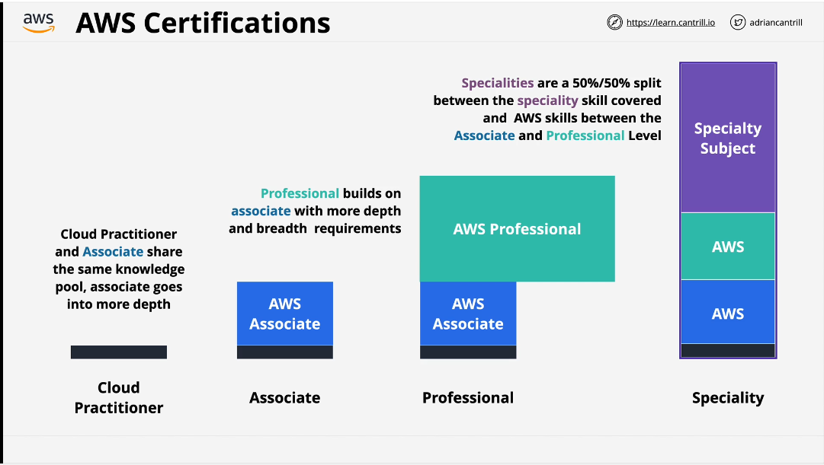

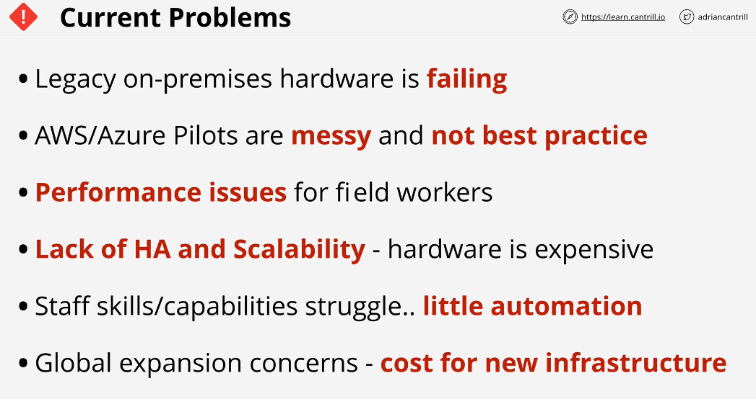

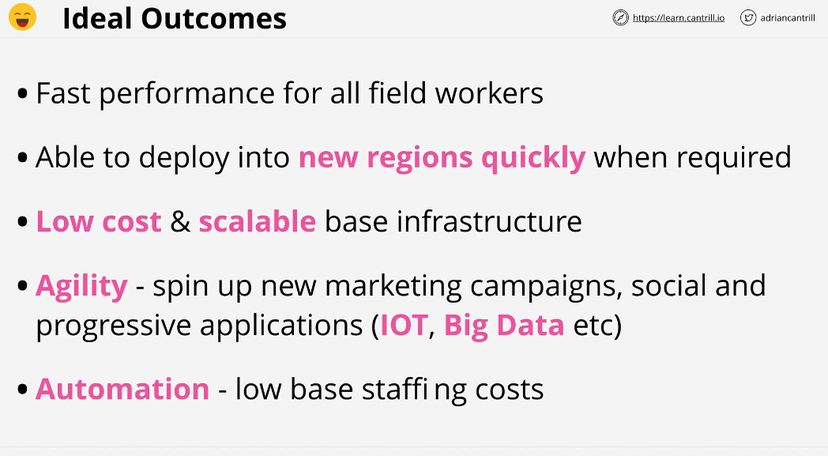

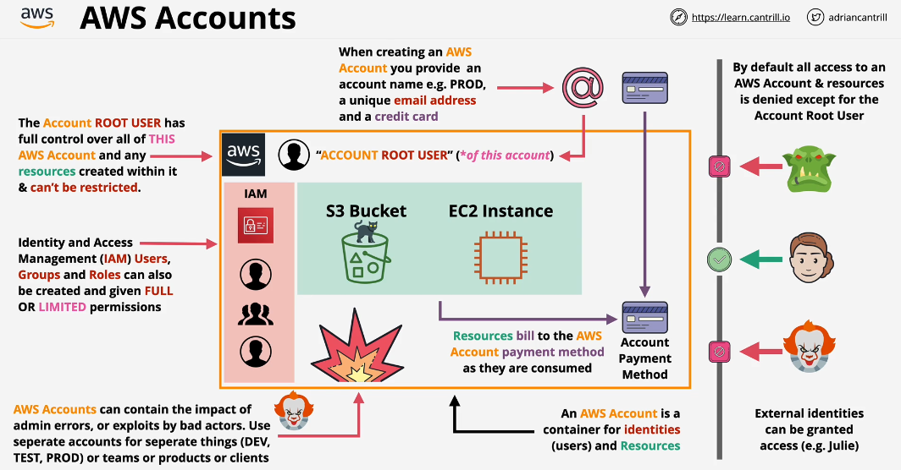

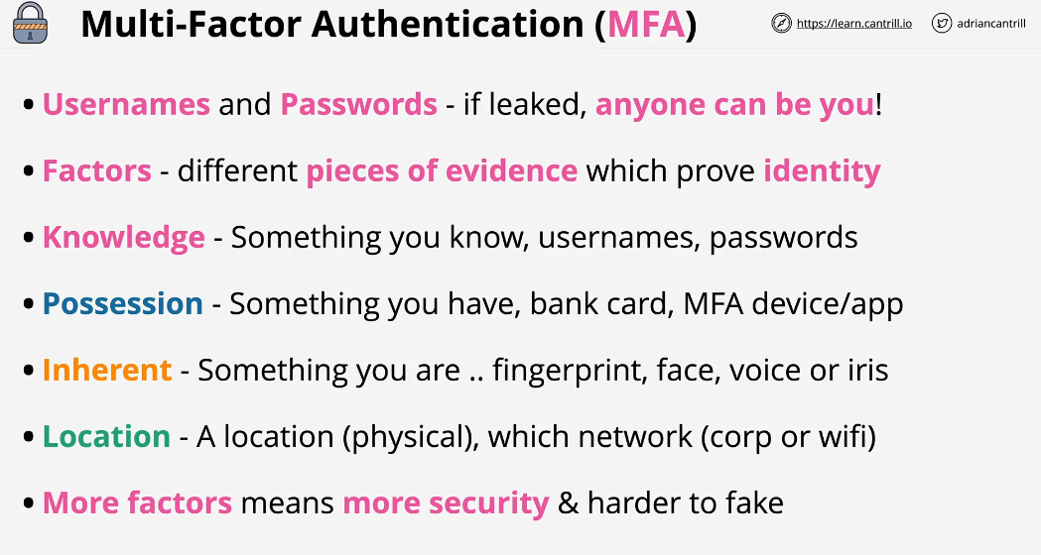

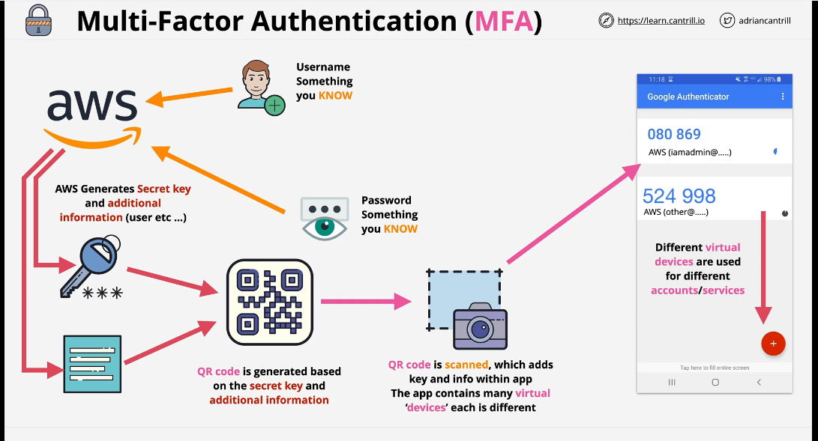

To configure MFA within AWS for a specific identity you need to activate MFA for that user. When you do so AWS generates secrete key and additional information and aws use these pieces to encode it in visual pattern called QR code.

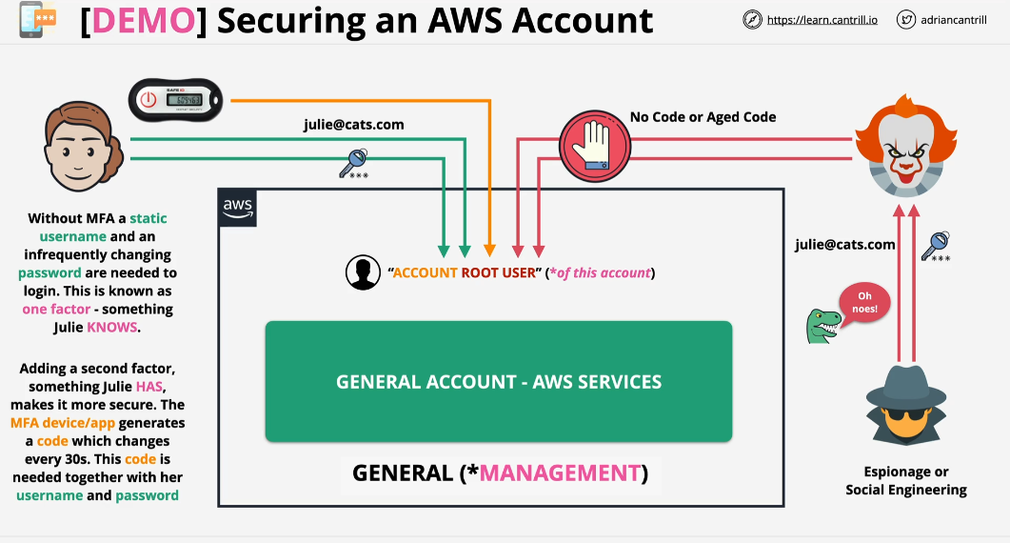

* Select security credentials from account setting option.

Budgets are really effective way that allows you to monitor you spends and configure alerts as you approach certain percentages of desired spends.

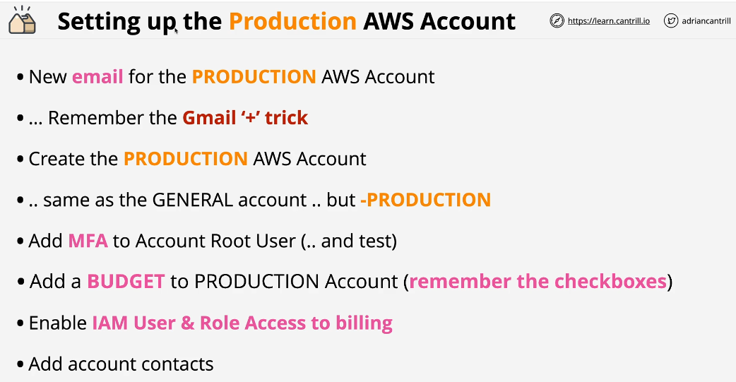

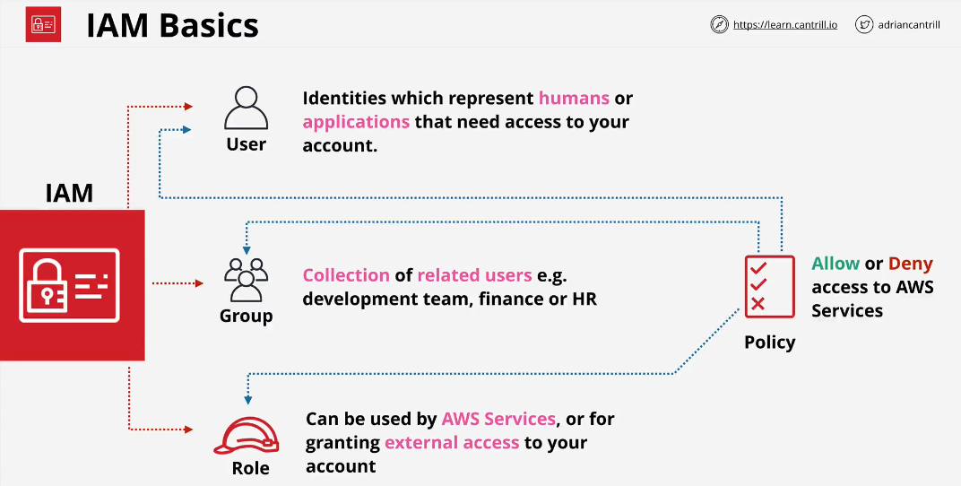

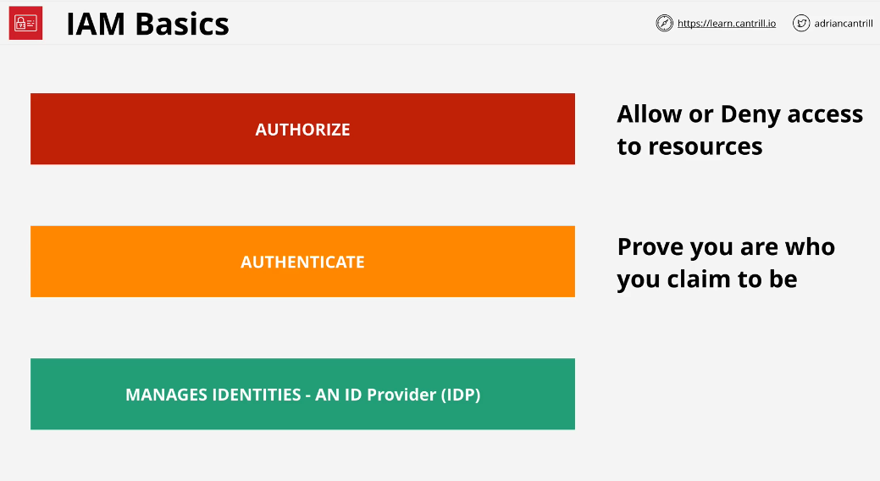

Authentication via command line is not done via username and password. It is done via IAM Access keys.

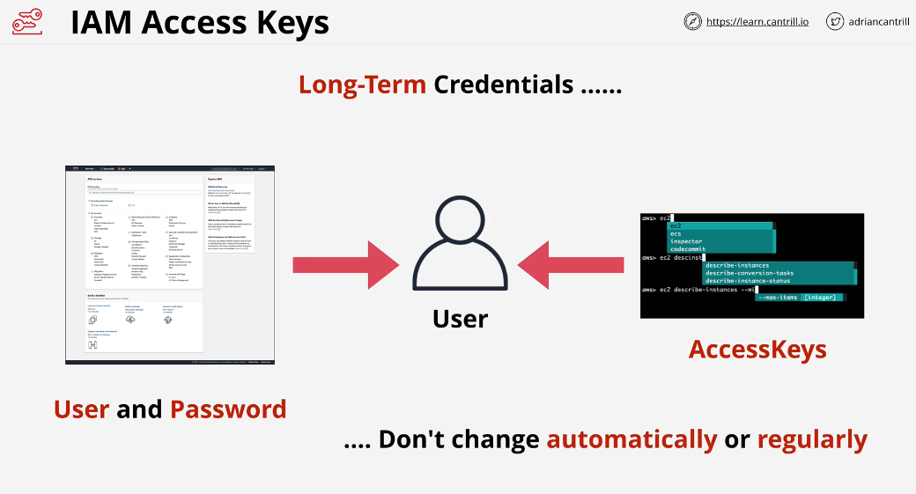

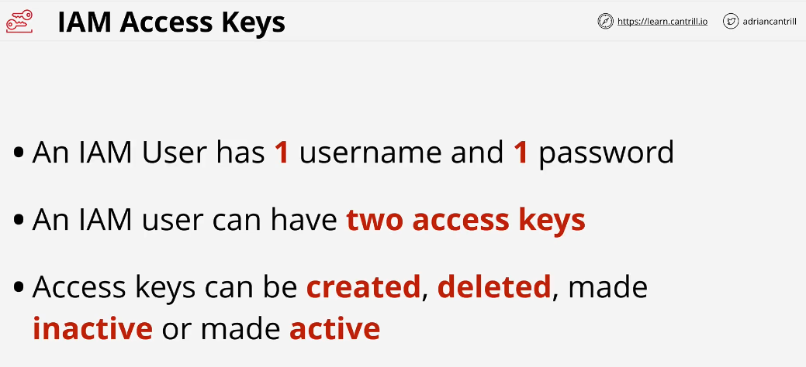

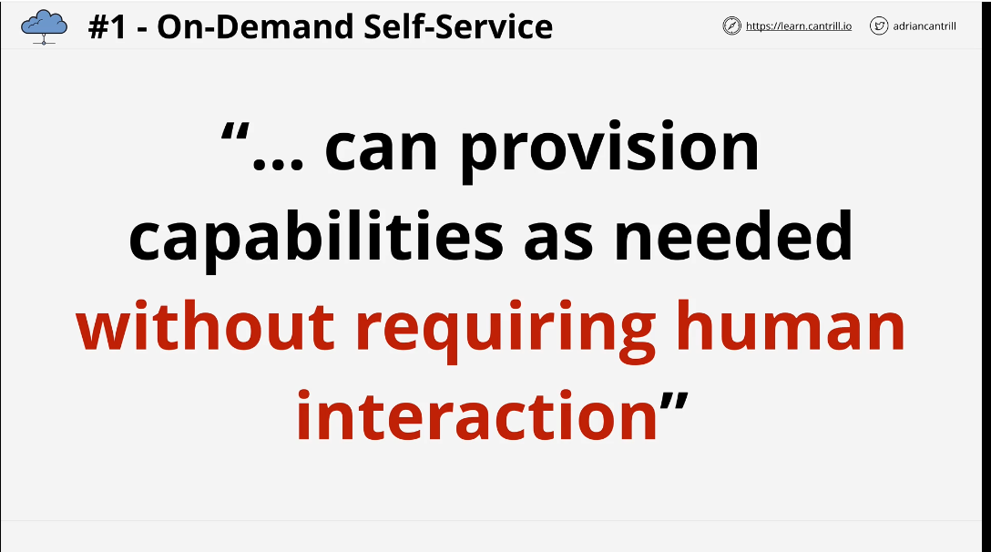

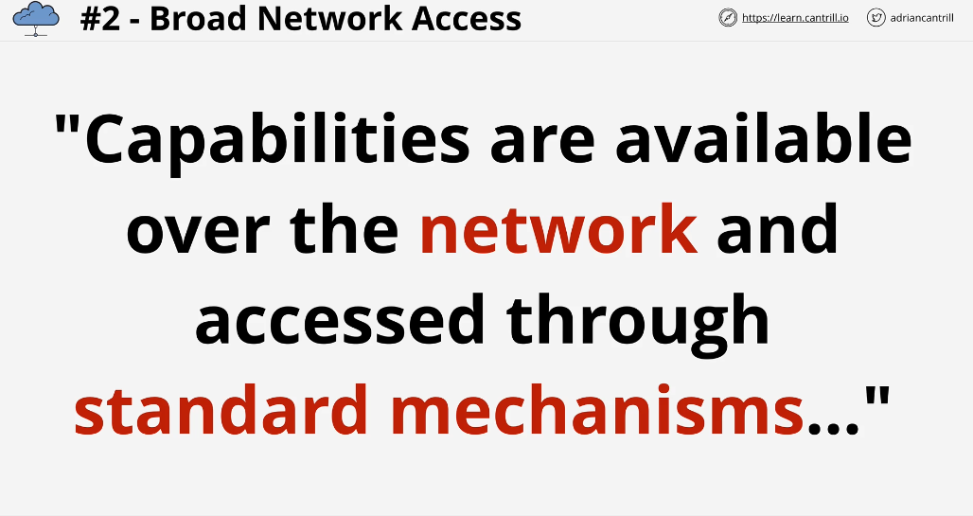

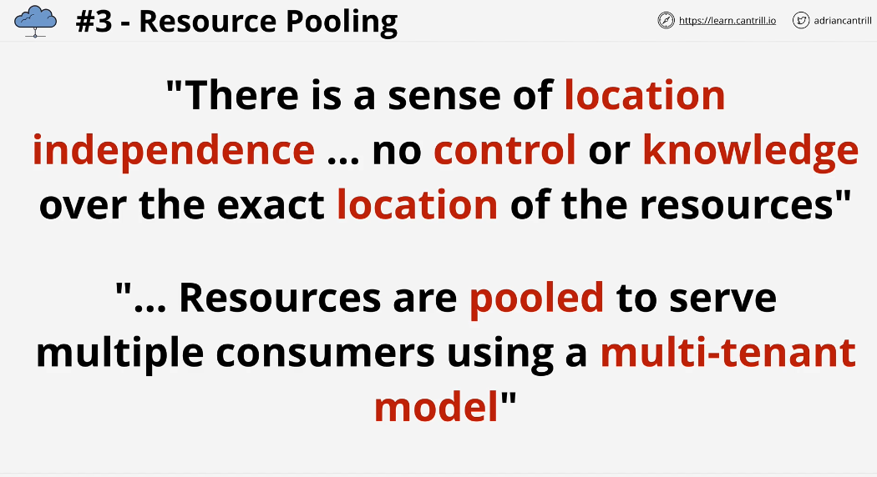

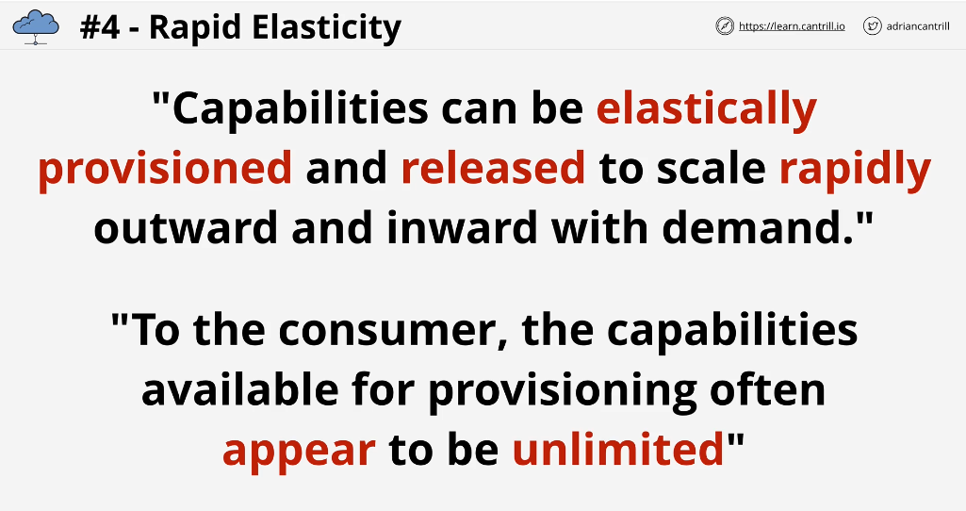

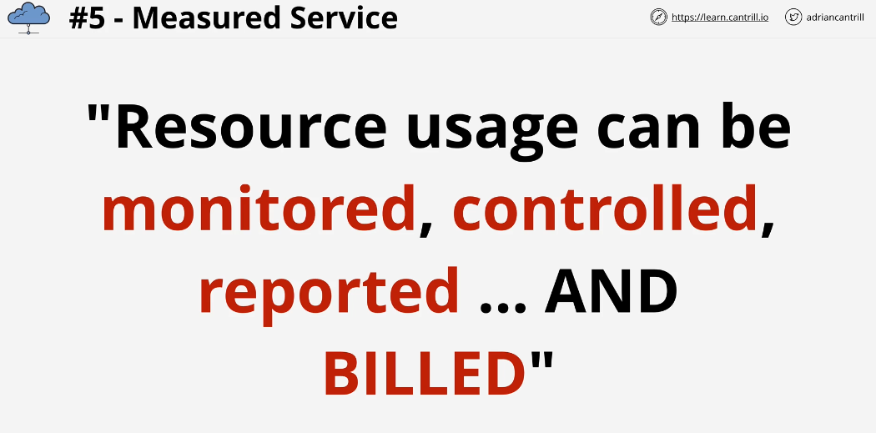

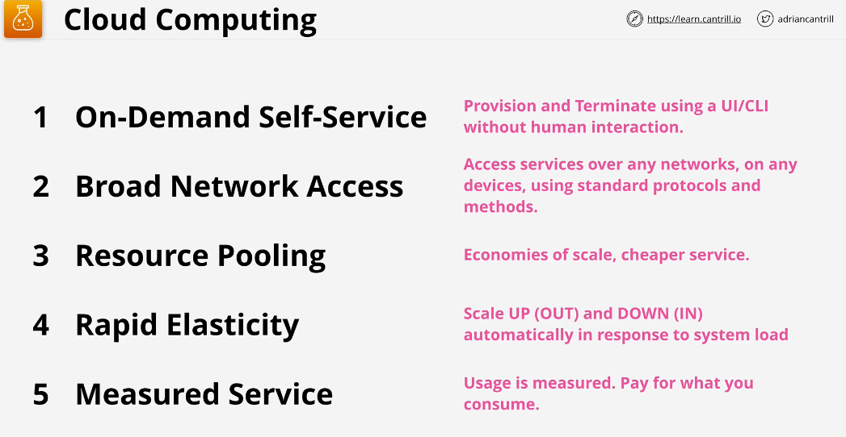

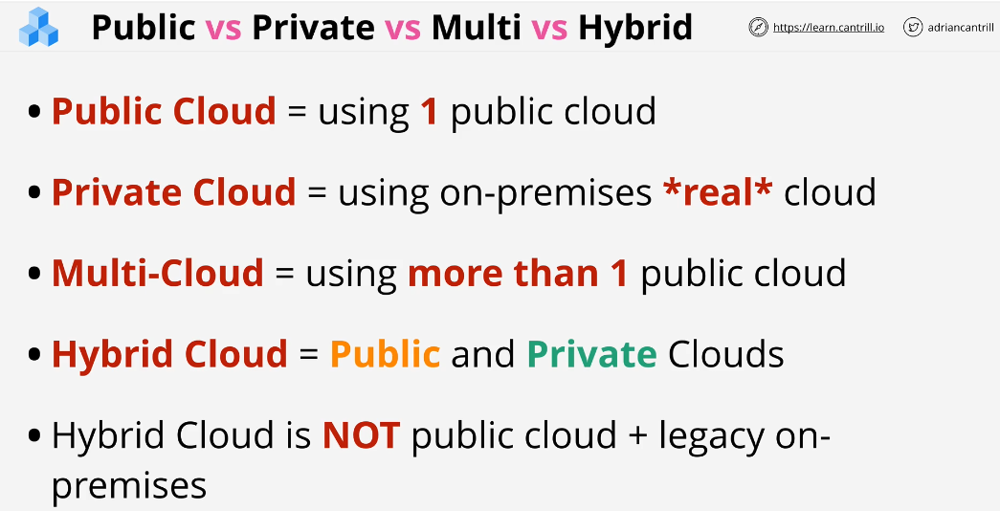

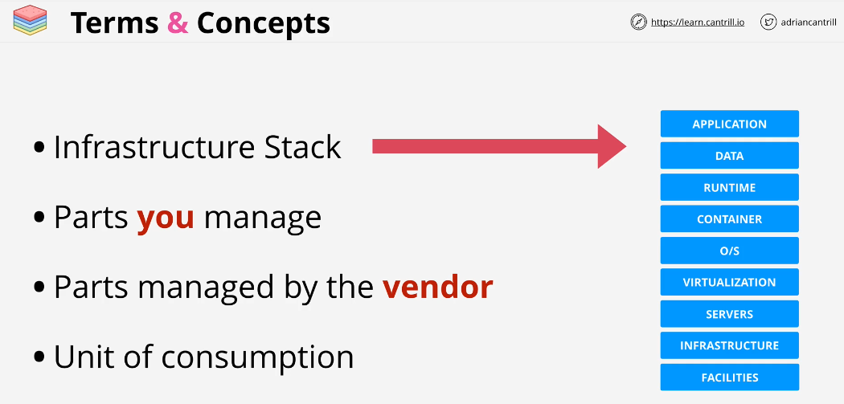

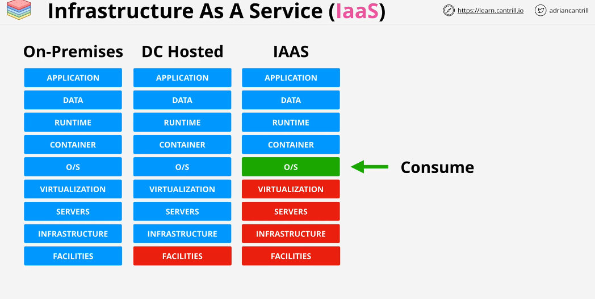

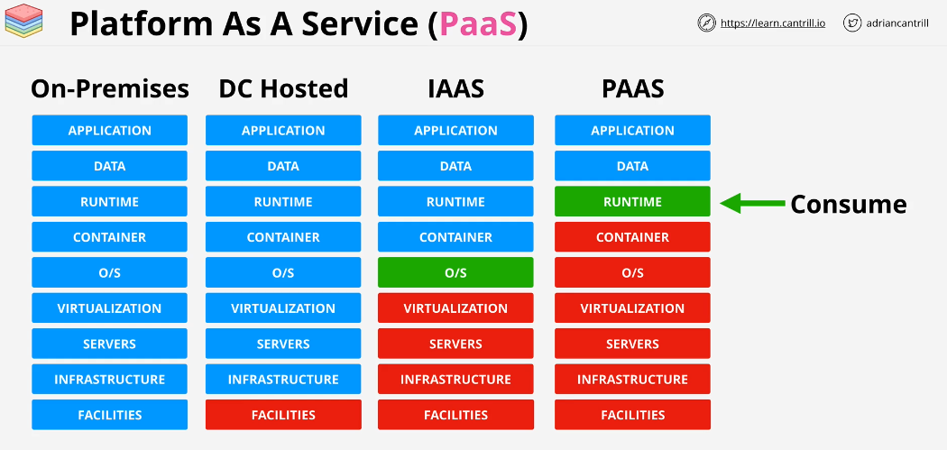

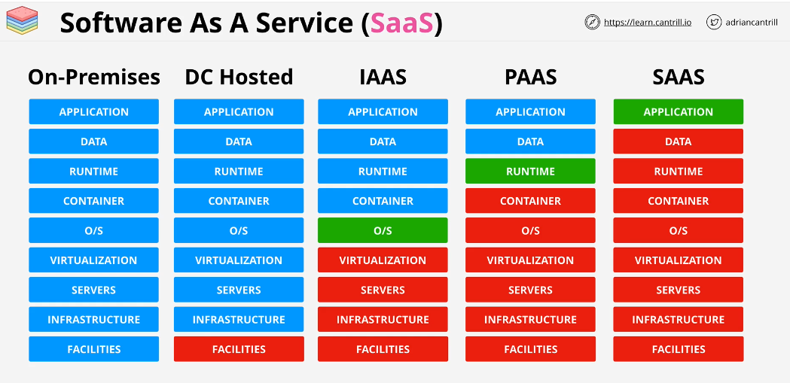

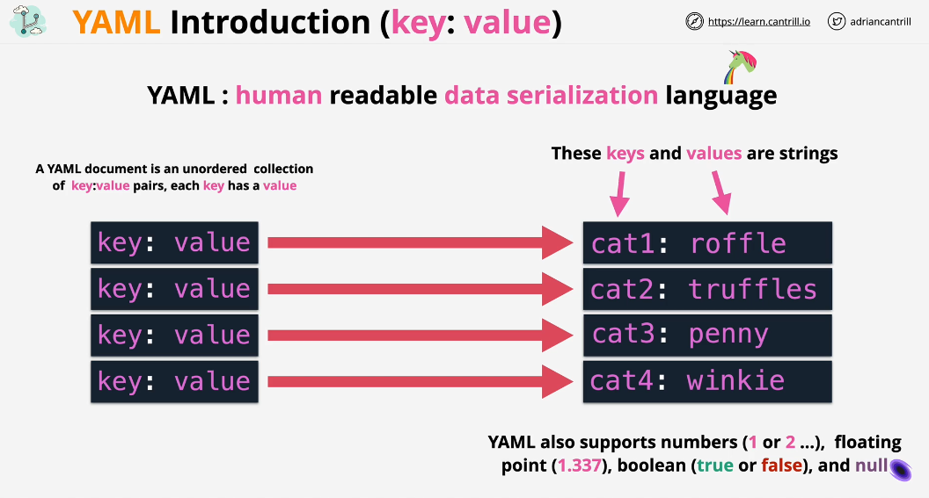

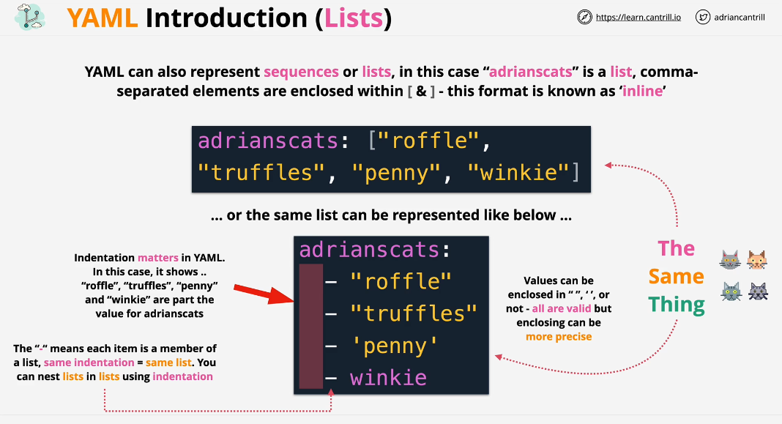

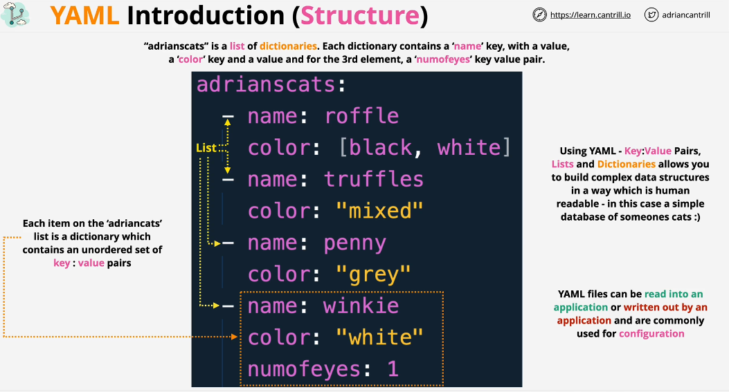

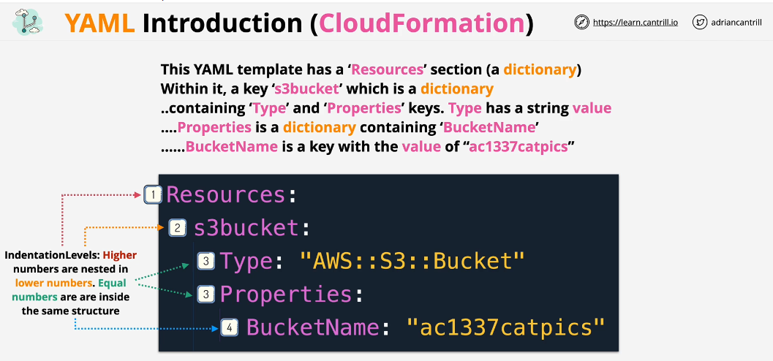

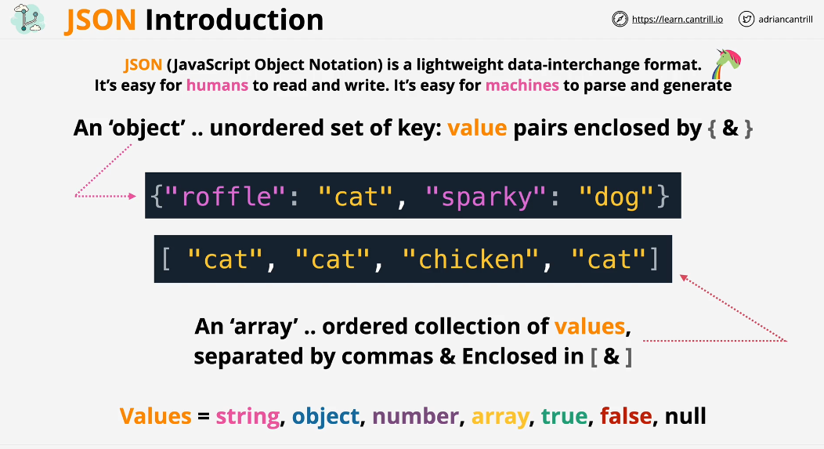

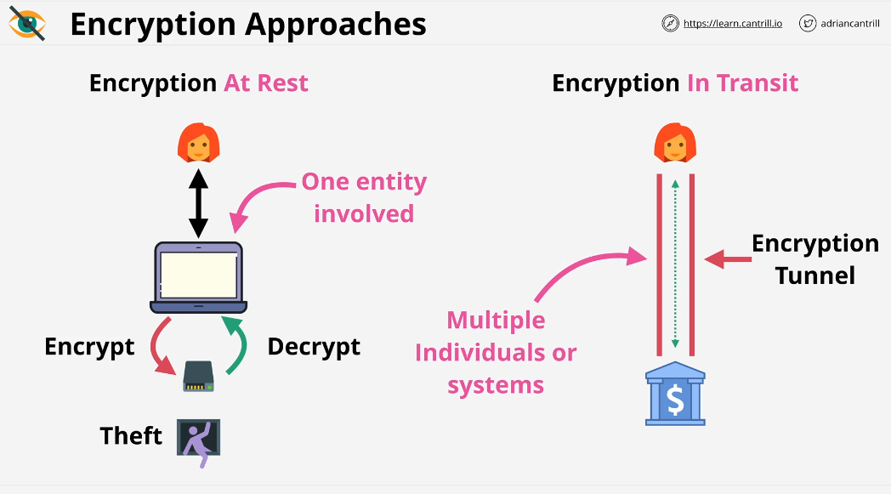

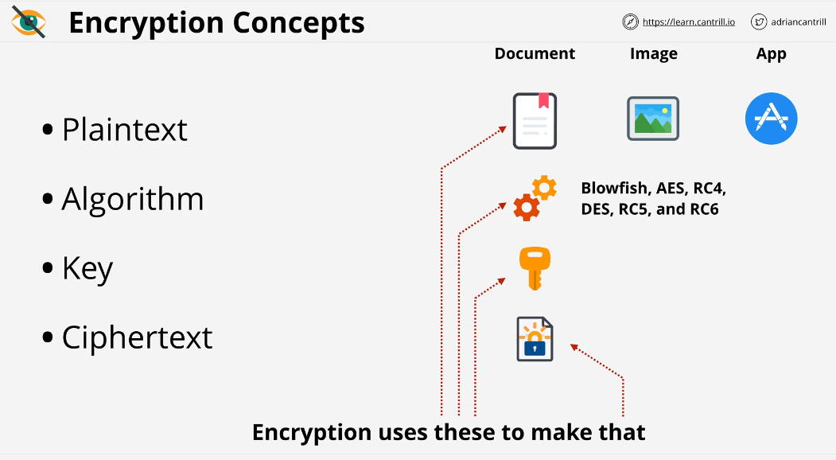

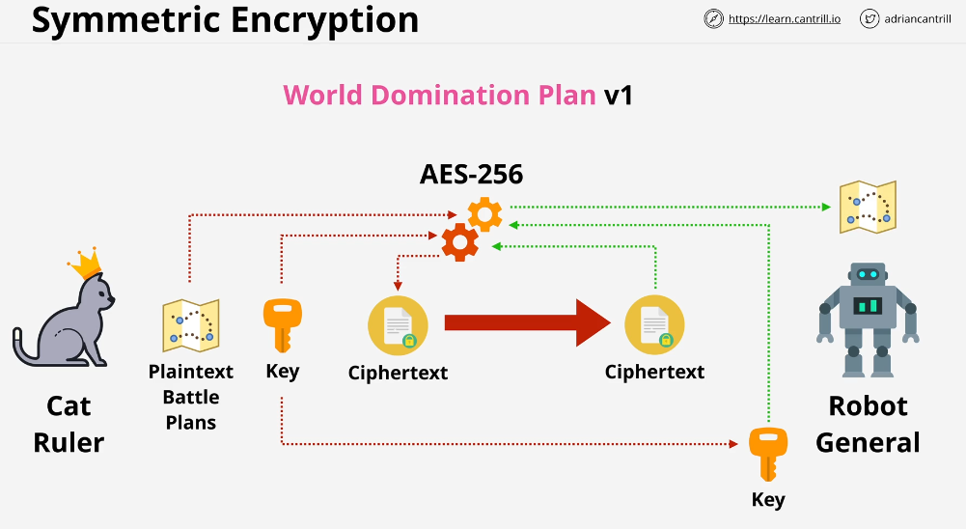

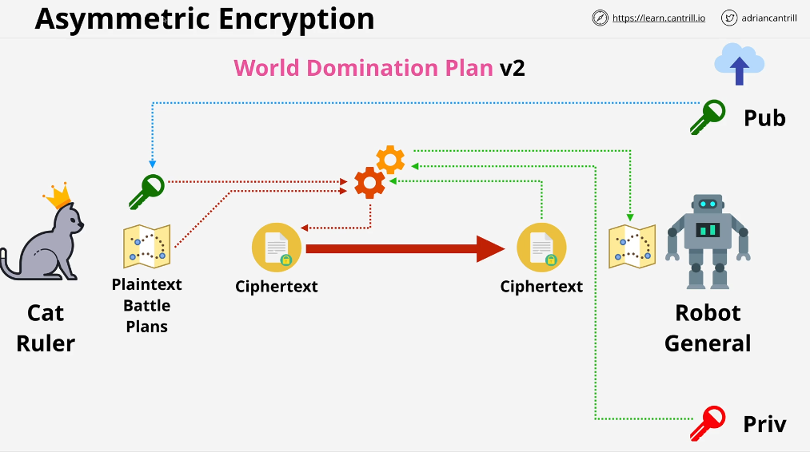

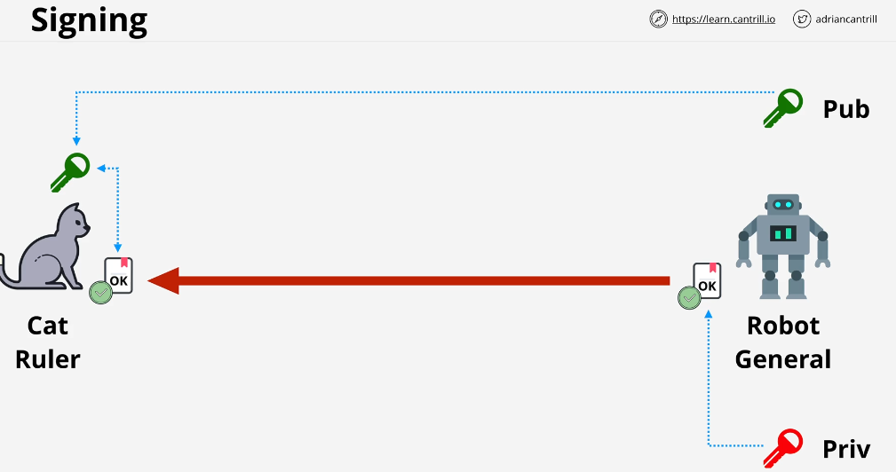

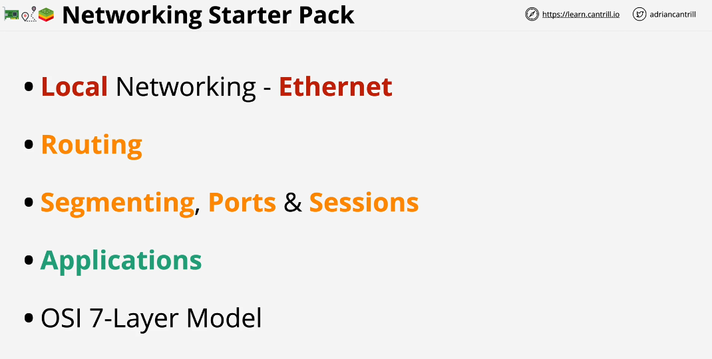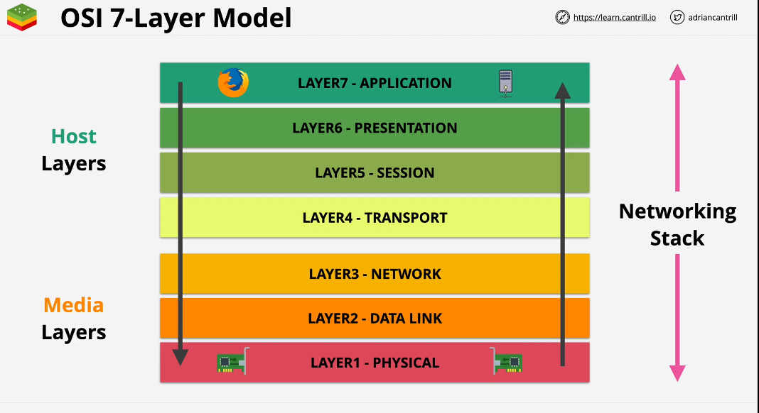

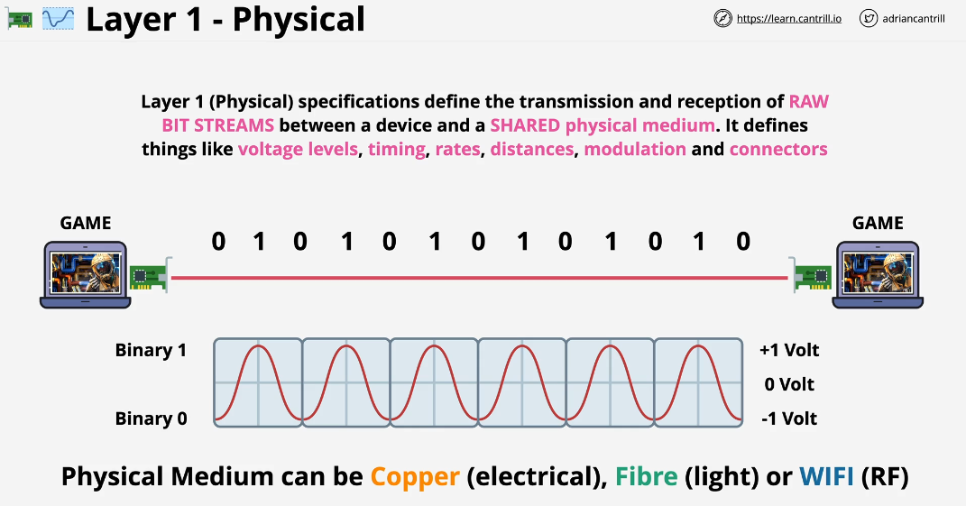

Whatever type of medium is used it needs a way of being able to carry unstructured information.

It’s a piece of cable that can be used to electrical signals between these two network interfaces.

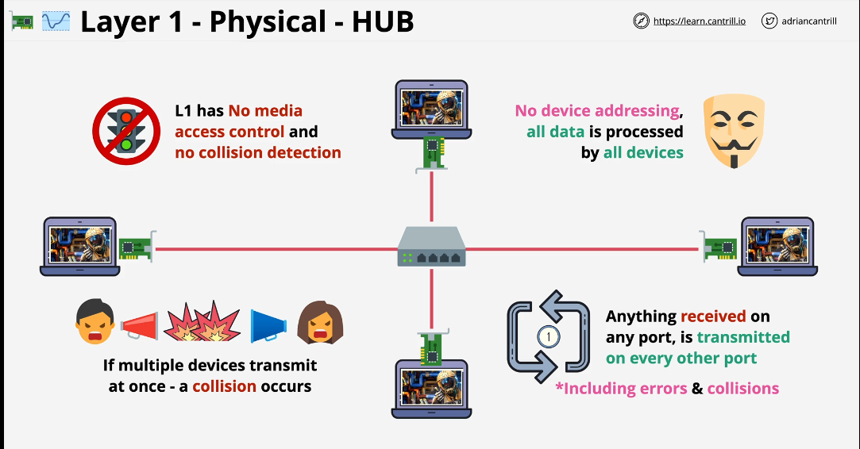

HUB has one job. Anything that hub receives on its port is re-transmitted to the all-other ports including any errors and collisions.

At layer 1, one laptop cannot address traffic directly to another. It’s a broadcast medium.

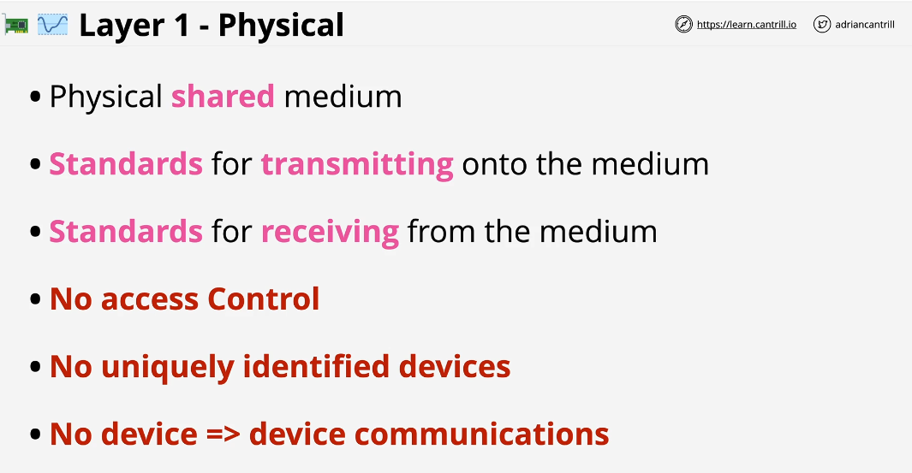

Layer 1 defines how data moves between all devices.

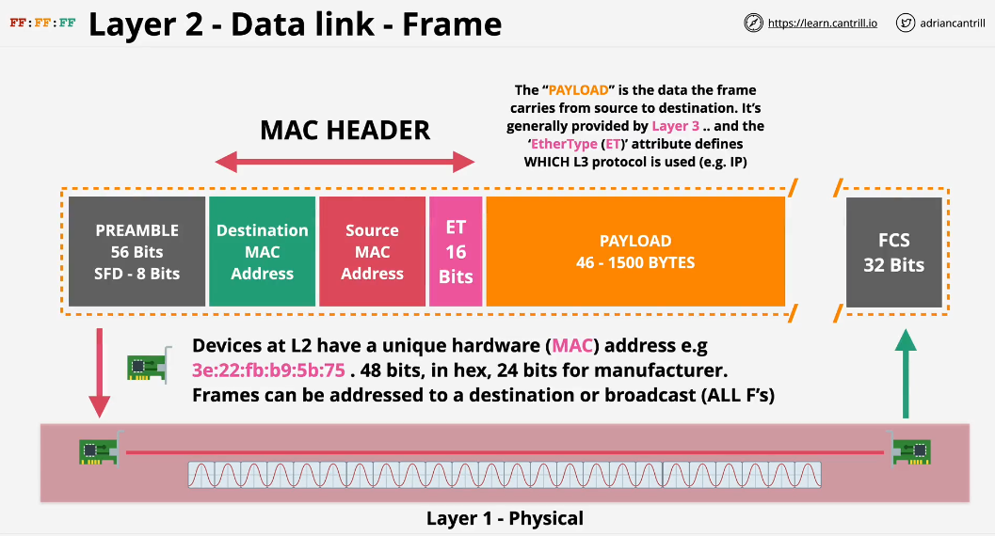

Layer 2 which is a data link layer runs over layer 1. Layer 2 network requires a functional layer 1 network to operate. Higher layers build on lower layers, adding features and capabilities.

Layer 2 rather than being focused on wave length or voltages, introduces the concept of Frame. Layer 2 also introduces the concept of MAC address.

Layer 2 uses Layer 1 as I mentioned. This means layer 2 or ethernet Frame can be transmitted on the shared physical medium by layer 1. This means that it can be converted into voltages, RF or light.

It is important to understand distinguish between layer 1 and 2. Layer 2 provides Frames. Layer 1 handle physical transmission and reception onto or from physical shared medium.

Frames have different sections.

1. Premable SDF (start Frame delimiter). It allows device to know start of the Frame.
2. Destination MAC Address
3. Source MAC address
4. ET (Ether Type)
5. Frame Check Sequence Which is used to identify Any error in the Frame

It is important to understand that Layer 2 Frame is generated by layer 2 software at the source side and passed to layer 1. That Raw data is transmitted on physical medium. It is taken off from physical medium at the destination side. It is passed to its layer 2 software that can interpret the Frame.

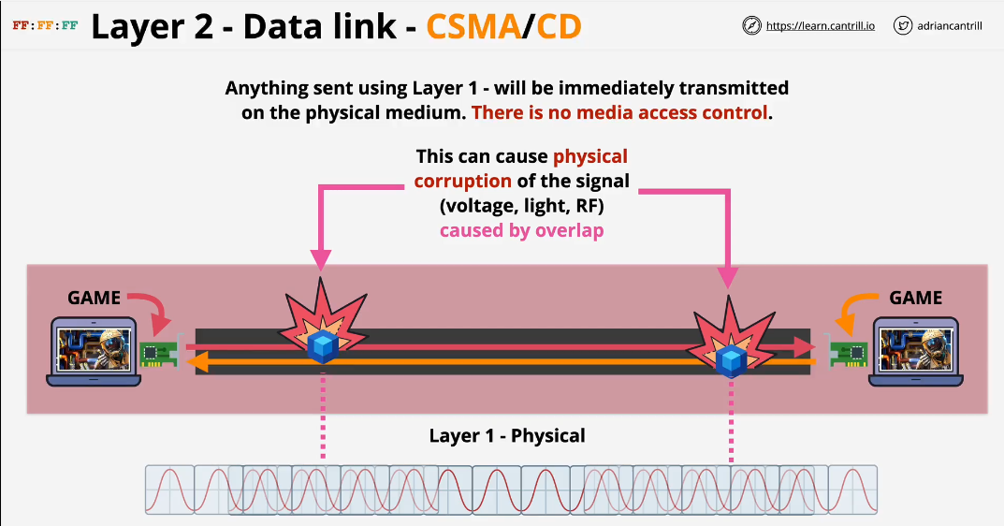

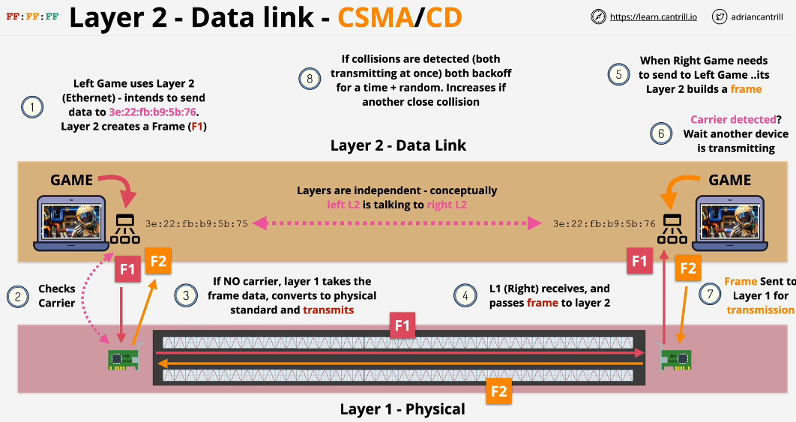

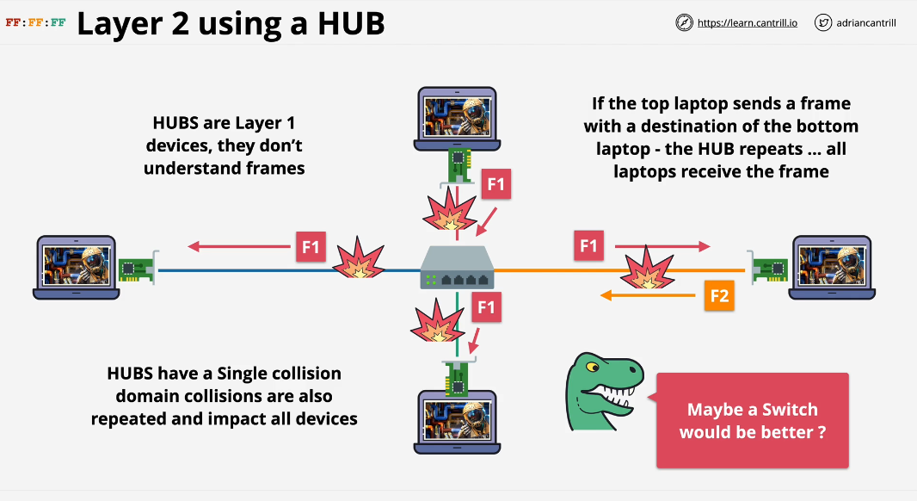

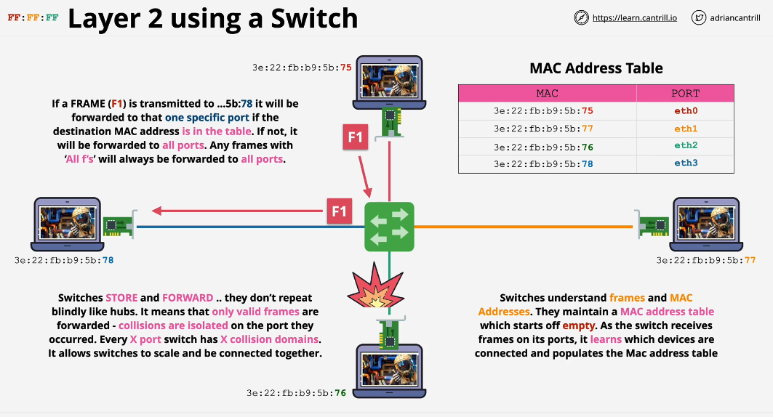

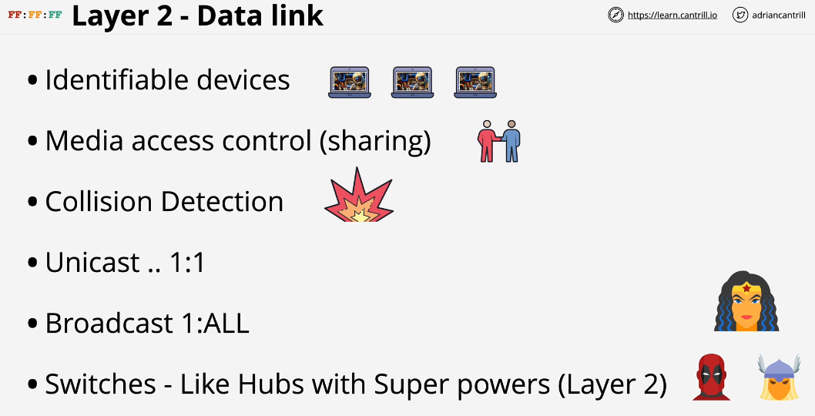

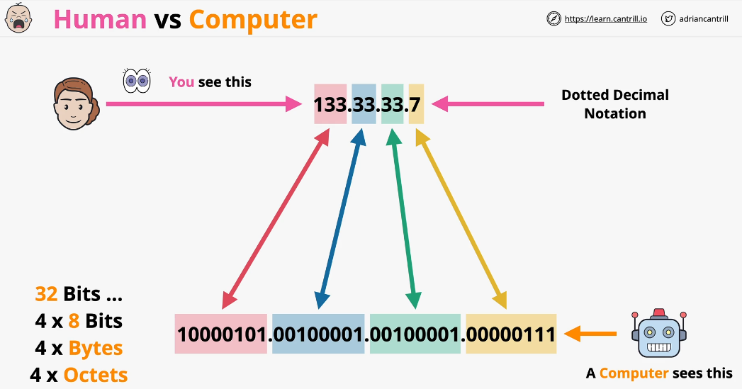

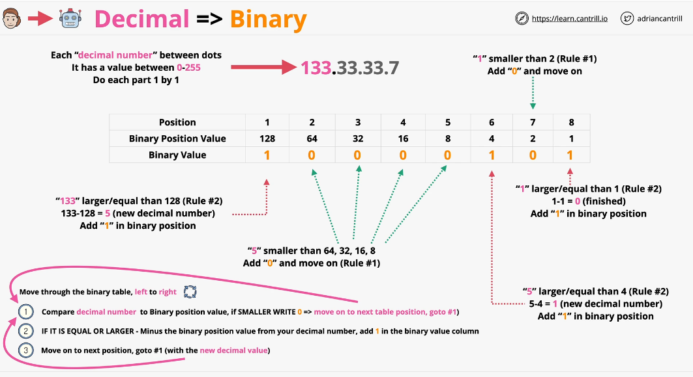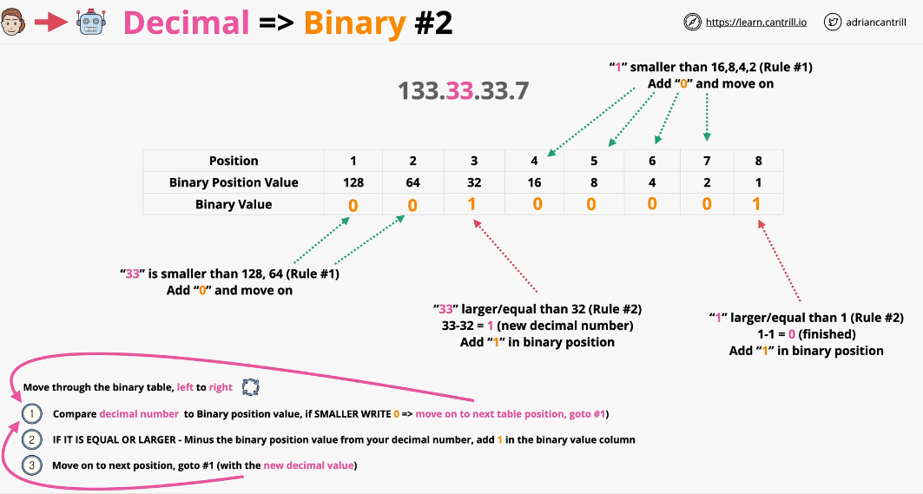

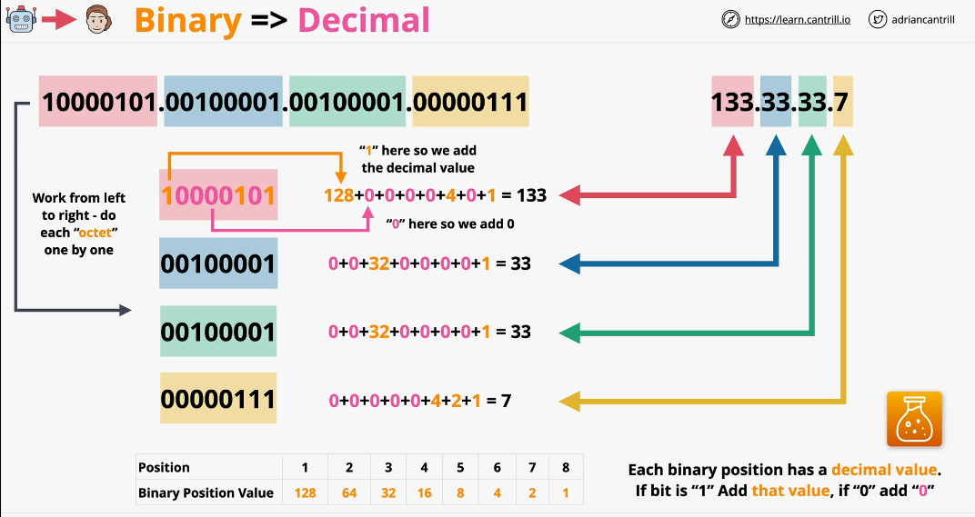

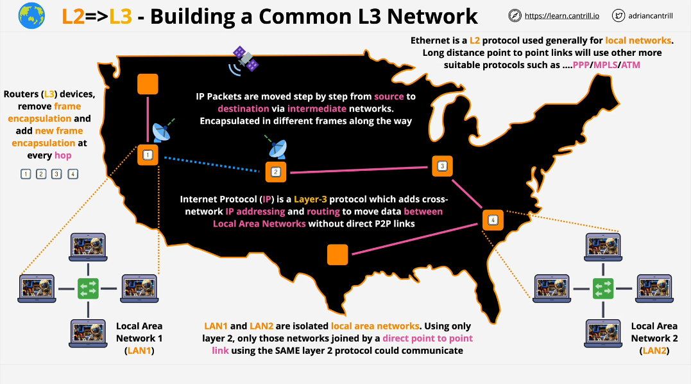

The Job of Layer 3 is to send data from one location to another.

Devices on each local network can communicate with each other but not outside of that local layer 2 network. To move Frame between different local networks which is known as internetworking, we need a Layer 3

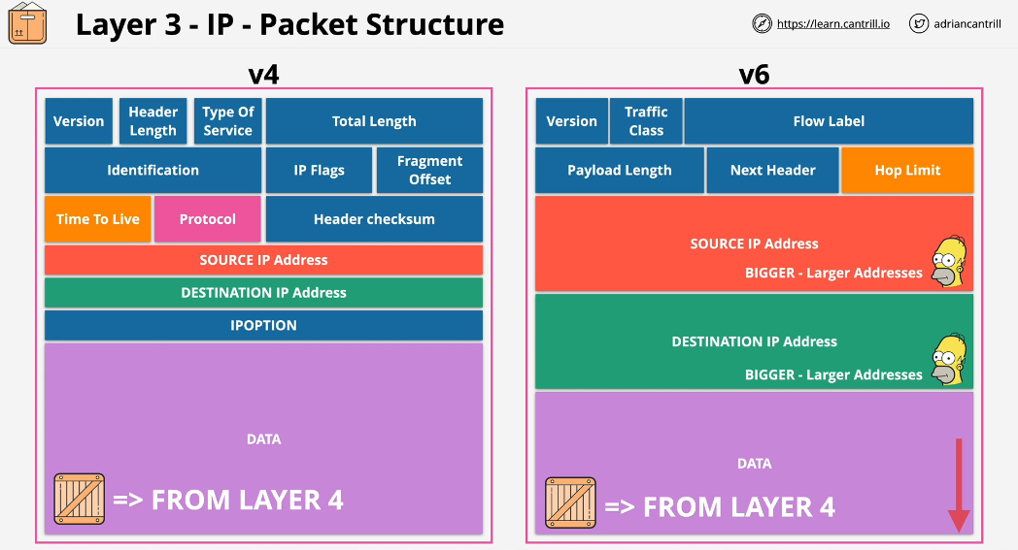

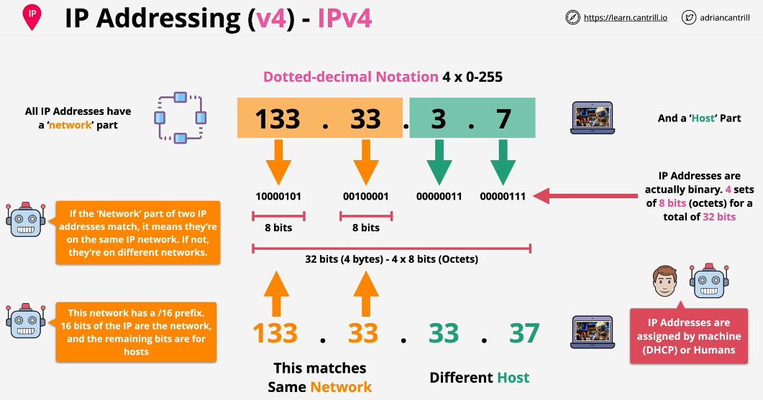

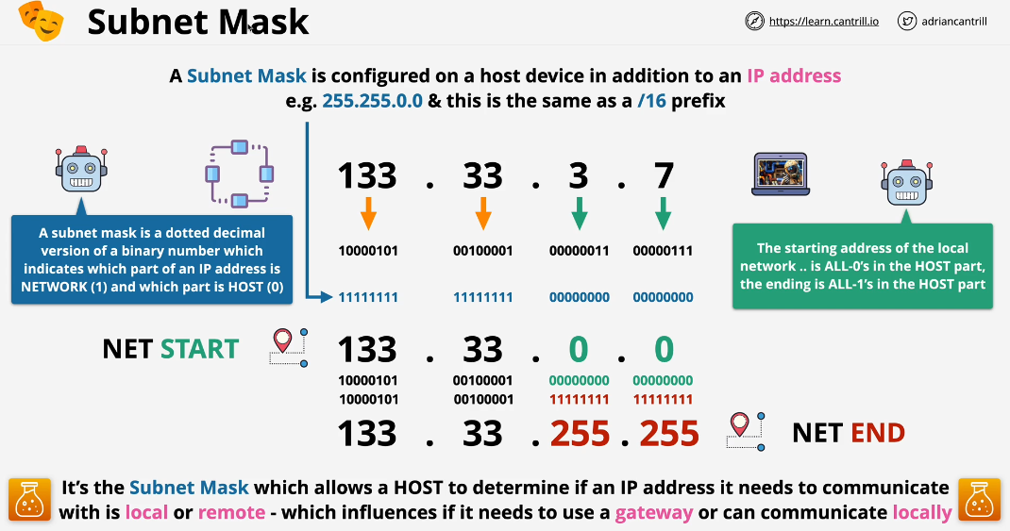

Subnet mask is used to identify which part of the IP Address is network part and which is host part

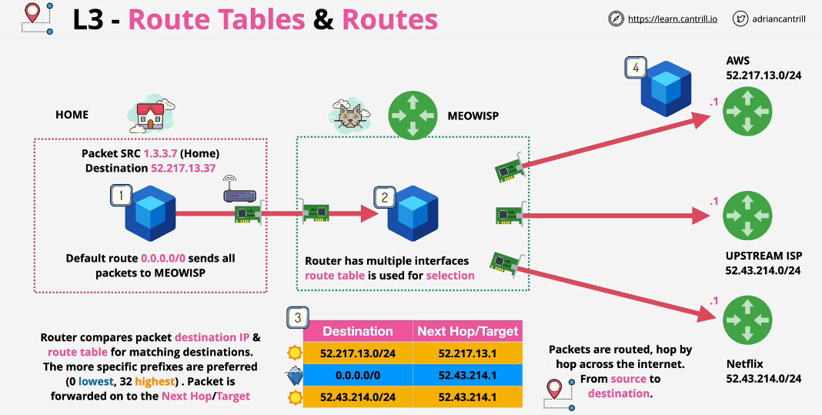

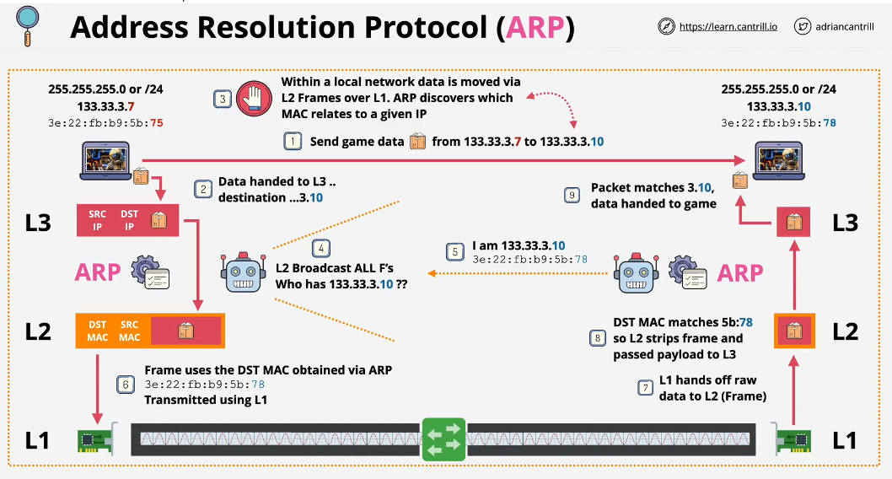

You don’t initially know a mac address. You need a protocol which can find a MAC address for a given IP address. ARP gives you a MAC address for a given IP address

ARP is a process which runs between Layer 3 and Layer 2. ARP broadcast on Layer 2 asking for MAC address of a given address.

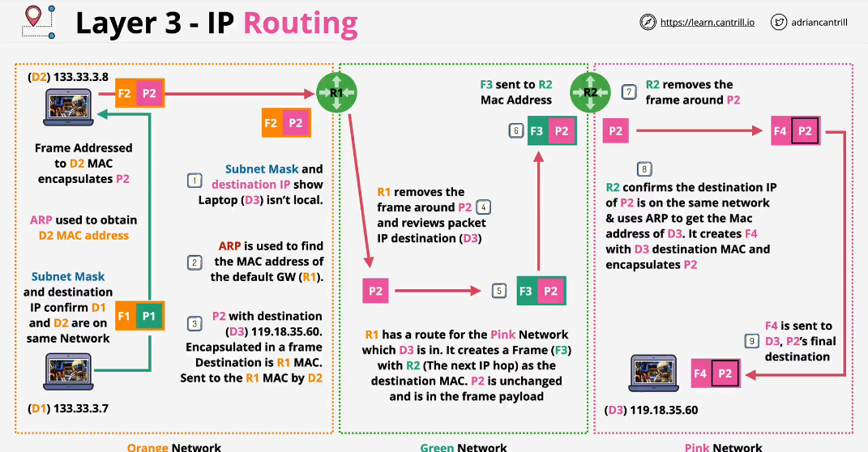

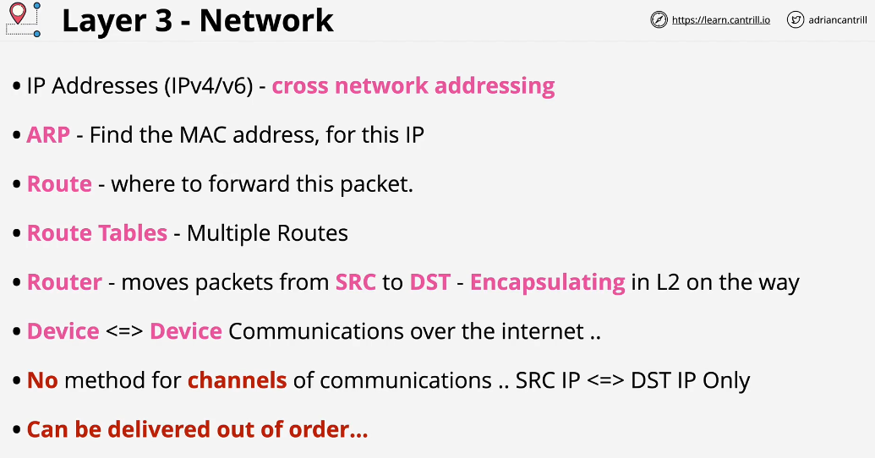

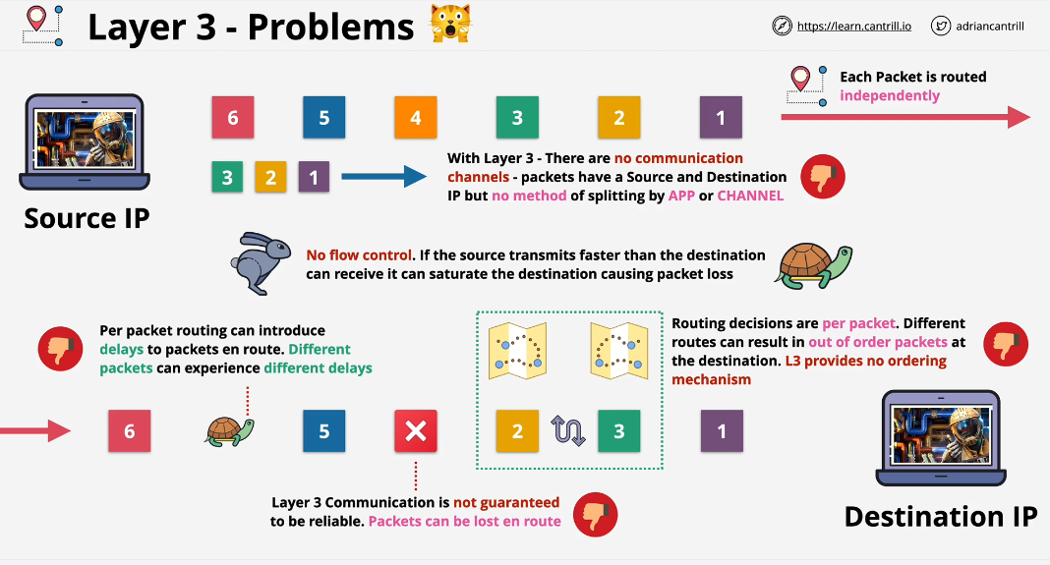

Layer 1 which relates to how Raw bits of data is transmitted to and received from physical shared medium. Then we talked about Layer 2 which adds identifiable devices, switches and media access control. Layers 3 adds Ip address and routing.

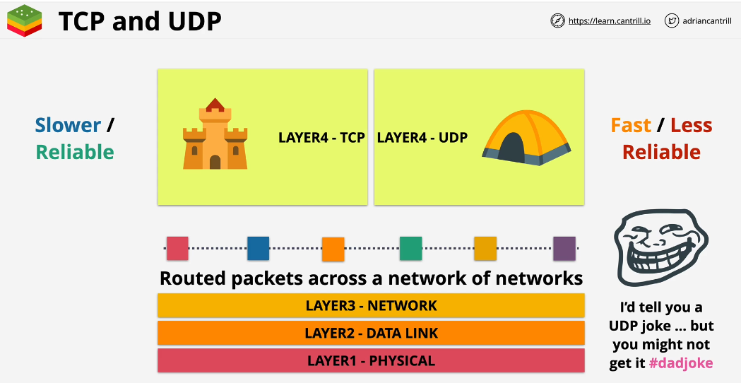

TCP is connection oriented protocol which means you need to setup a connection between two devices and once setup, it creates a bidirectional channel of communication.

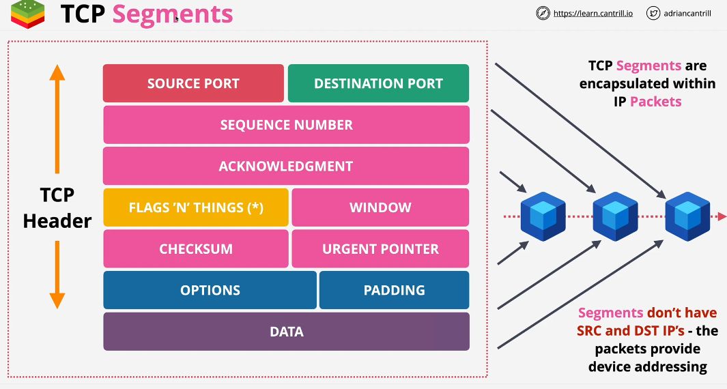

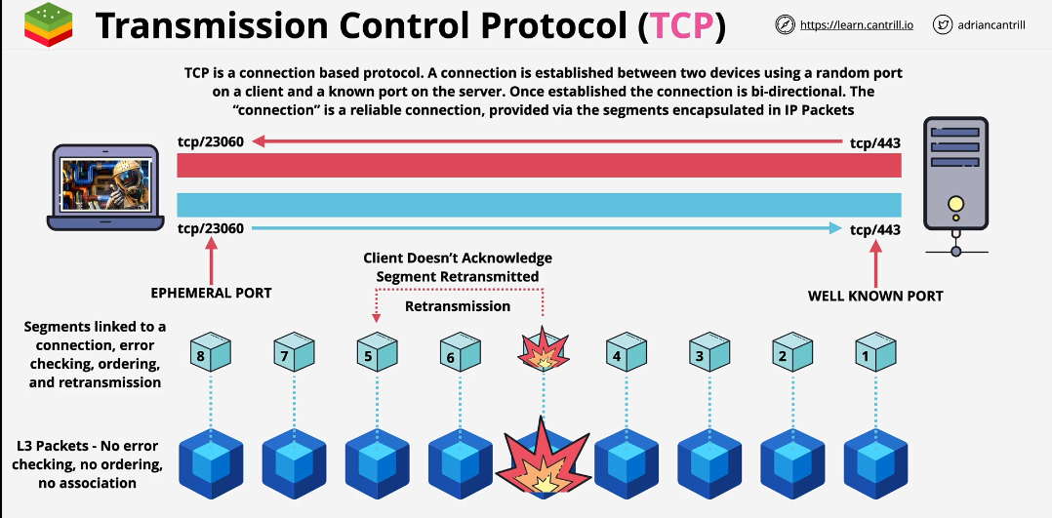

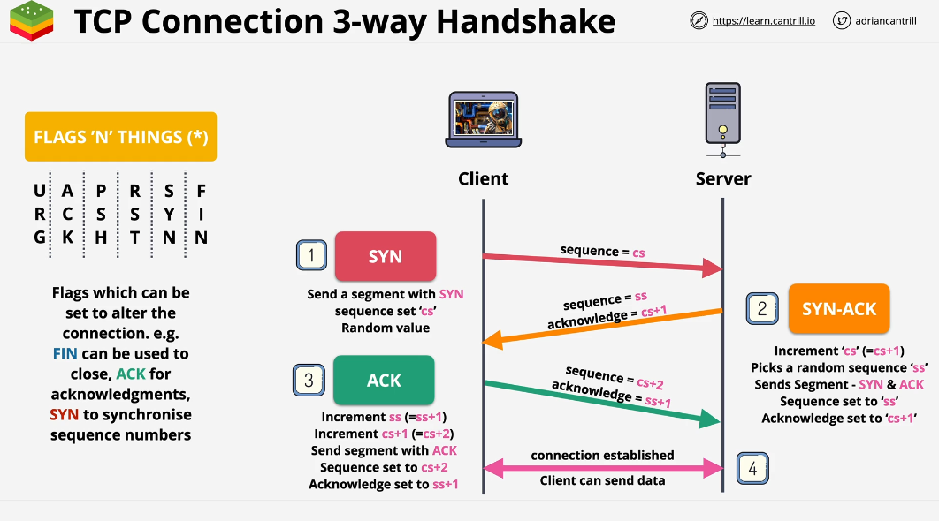

TCP is a connection based, you cannot send data without first creating connection.

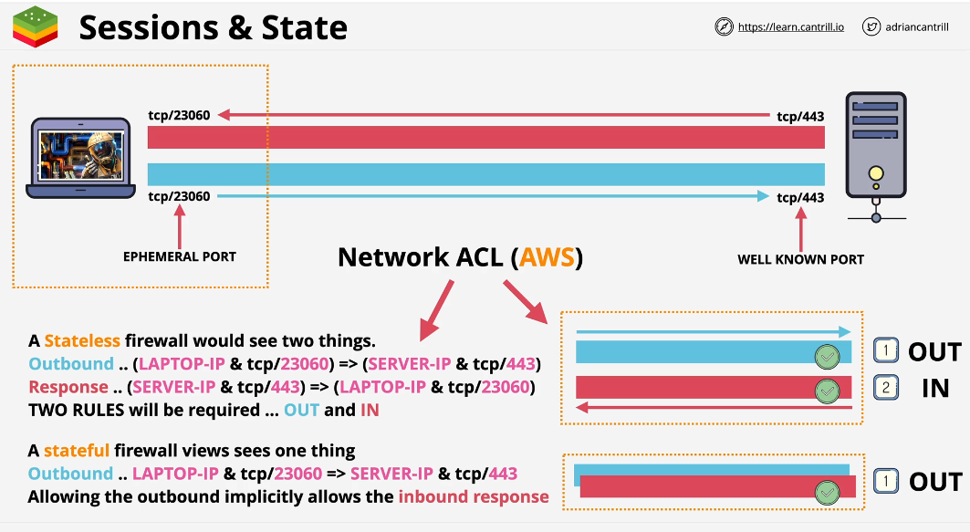

At this point of OSI model, we have the ability to create stable, consistent communication channel which is bidirectional between two devices.

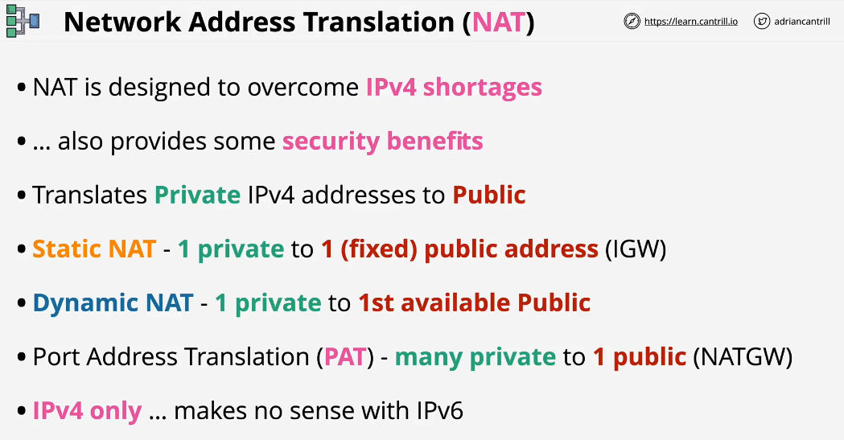

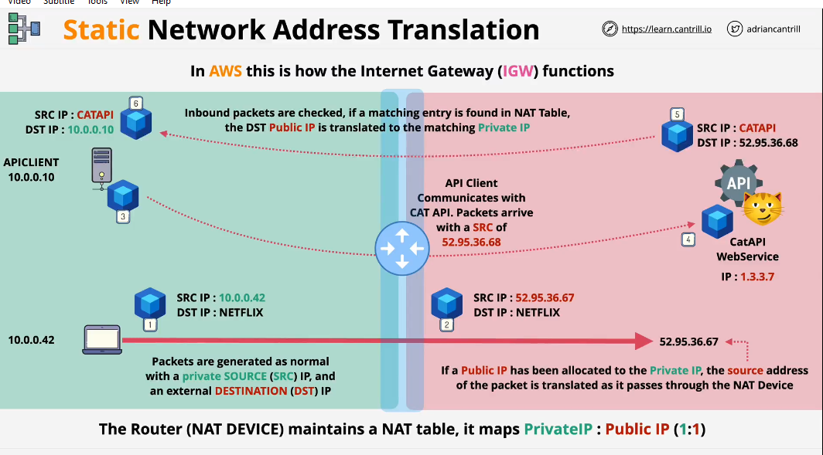

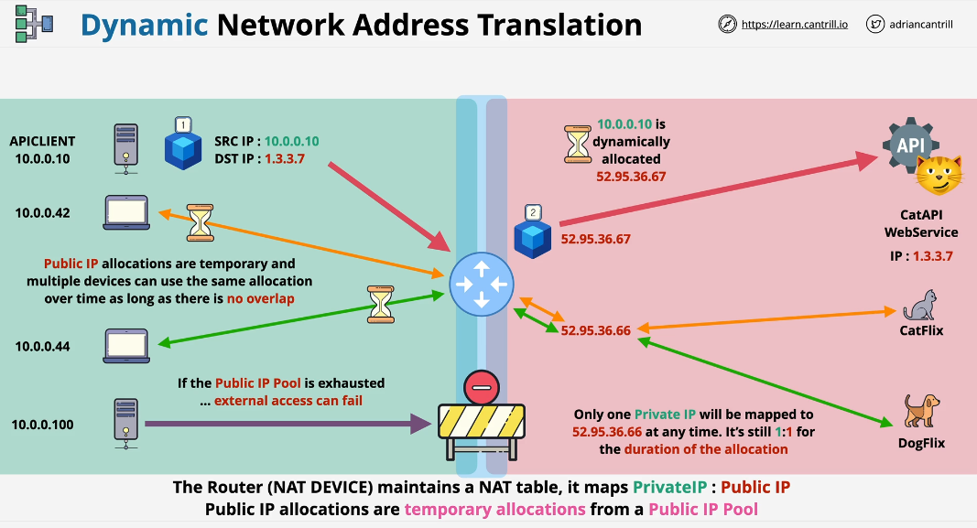

The principle of Dynamic NAT is similar to static except devices are not allocated permanent Public IP. Instead one allocated temporarily from pool.

